VISVESVARAYA TECHNOLOGICAL UNIVERSITY
“JnanaSangama”, Belgaum -590014, Karnataka.

LAB REPORT
on
Object Oriented Java Programming (23CS3PCOOJ)
Submitted by
REEYA POKHREL (1BF24CS249)
in partial fulfillment for the award of the degree of
BACHELOR OF ENGINEERING
in

B.M.S. COLLEGE OF ENGINEERING
(Autonomous Institution under VTU)
BENGALURU-560019
Aug-2025 to Jan-2026

B.M.S. College of Engineering,
Bull Temple Road, Bangalore 560019
(Affiliated To Visvesvaraya Technological University, Belgaum)
Department of Computer Science and Engineering

CERTIFICATE
This is to certify that the Lab work entitled “Object Oriented Java Programming (23CS3PCOOJ)” carried out by REEYA POKHREL(1BF24CS249), who is bonafide student of B.M.S. College of Engineering. It is in partial fulfilment for the award of Bachelor of Engineering in Computer Science and Engineering of the Visvesvaraya Technological University, Belgaum. The Lab report has been approved as it satisfies the academic requirements in respect of an Object-Oriented Java Programming (23CS3PCOOJ) work prescribed for the said degree.

Dr. Seema Patil  Associate Professor  Department of CSE, BMSCE | Dr. Kavitha Sooda  Professor & HOD  Department of CSE, BMSCE

Index
Sl.  No. | Date | Experiment Title | Page No.
1 | 23/09/2025 | Implement java program on Quadratic equation | 4-5
2 | 14/09/2025 | Implement java program to calculate SGPA | 6-9
3 | 14/10/2025 | Implement java program on Book Class | 10-12
4 | 04/11/2025 | Implement java program on Abstract class | 13-15
5 | 04/11/2025 | Implement java program on Bank Management | 16-23
6 | 18/11/2025 | Implement java program on Packages | 24-26
7 | 25/11/2025 | Implement java program on Exceptions | 27-28
8 | 09/12/2025 | Implement java program on Multithreading | 29-30

Github Link:
(https://github.com/reeyapokhrel/Java-Programs)

Program 1
Develop a Java program that prints all real solutions to the quadraticequation ax2+bx+c = 0. Read in a, b, c and use the quadratic formula. Ifthe discriminate b2-4ac is negative, display a message stating that there are no real solutions.

CODE:

import java.util.Scanner;
import java.lang.Math;
class Quadratic
{
public static void main(String[]args)
{
double a,b,c;
double r1,r2,d;
Scanner in= new Scanner(System.in);
System.out.println("enter the first number");
a= in.nextDouble();
System.out.println("enter the second number");
b= in.nextDouble();
System.out.println("enter the third number");
c= in.nextDouble();
if(a==0)
{
System.out.println("The quadratic equation does not exist");
System.out.println("Enter a non zero value");
a=in.nextDouble();
}
d=b*b-4*a*c;
if (d==0)
{
r1=(-b)/(2*a);
System.out.println("The roots are real and equal");
System.out.println(r1);
}
else if(d>0)
{
r1=((-b)+(Math.sqrt(d)))/(double)(2*a);
r2=((-b)-(Math.sqrt(d)))/(double)(2*a);
System.out.println("the roots are real and unequal");
System.out.println(r1);
System.out.println(r2);
}
else if(d<0)
{
r1= (-b)/(2*a);
r2 = Math.sqrt(-d)/(2*a);
System.out.println("The roots are imaginary");
System.out.println(r1);
System.out.println(r2);
}
}
}

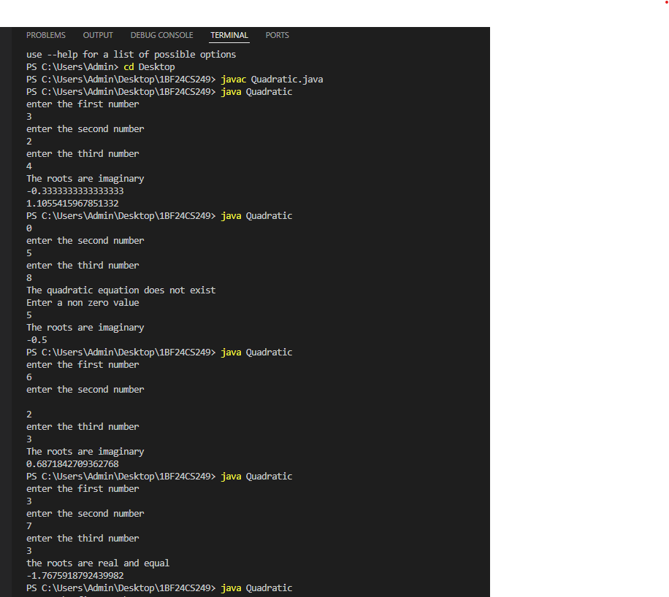

Program 2
Develop a Java program to create a class Student with members usn,name, an array credits and an array marks. Include methods to accept and display details and a method to calculate SGPA of a student.

CODE:

import java.util.Scanner;

class Subject {
int subjectMarks;
int credits;
int grade;

public Subject() {
this.subjectMarks = 0;
this.credits = 0;
this.grade = 0;
}
}

class Student {
String name;
String usn;
double SGPA;
Scanner s;
Subject[] subject;

public Student() {
s = new Scanner(System.in);
subject = new Subject[10];
for (int i = 0; i < 10; i++) {
subject[i] = new Subject();
}
}

public void getStudentDetails() {
System.out.print("Enter student name: ");
name = s.nextLine();
System.out.print("Enter student USN: ");
usn = s.nextLine();
}

public void getMarks() {
for (int i = 0; i < 8; i++) {
System.out.print("Enter marks for subject " + (i + 1) + ": ");
subject[i].subjectMarks = s.nextInt();
System.out.print("Enter credits for subject " + (i + 1) + ": ");
subject[i].credits = s.nextInt();

subject[i].grade = (subject[i].subjectMarks / 10) + 1;

if (subject[i].grade == 11) {
subject[i].grade = 10;
}
if (subject[i].grade <= 4) {
subject[i].grade = 0;
}
}
}
public void computeSGPA() {
int effectiveScore = 0;
int totalCredits = 0;

for (int i = 0; i < 8; i++) {
effectiveScore += (subject[i].grade * subject[i].credits);
totalCredits += subject[i].credits;
}

SGPA = (double) effectiveScore / totalCredits;
}

public void display() {
System.out.println("\nStudent Details:");
System.out.println("Name: " + name);
System.out.println("USN: " + usn);
System.out.println("SGPA: " + SGPA);
}
}

public class SGPA {
public static void main(String[] args)
{
Scanner scanner = new Scanner(System.in);
System.out.print("Enter number of students: ");
int n = scanner.nextInt();
scanner.nextLine();

Student[] students = new Student[n];

for (int i = 0; i < n; i++) {
System.out.println("\nEnter details for student " + (i + 1) + ":");
students[i] = new Student();
students[i].getStudentDetails();
students[i].getMarks();
students[i].computeSGPA();
}

System.out.println("\n--- Student Results ---");
for (int i = 0; i < n; i++) {
students[i].display();
}

scanner.close();
}
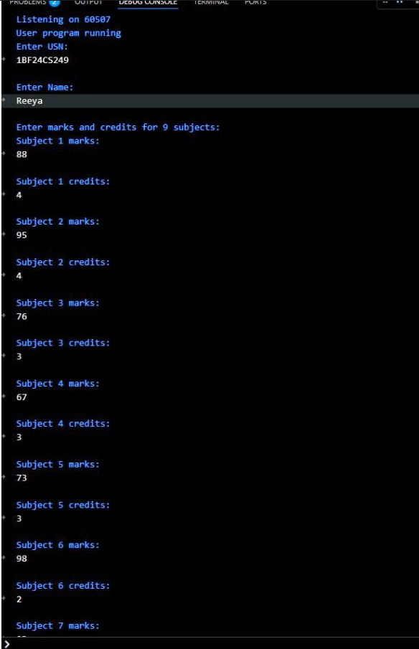
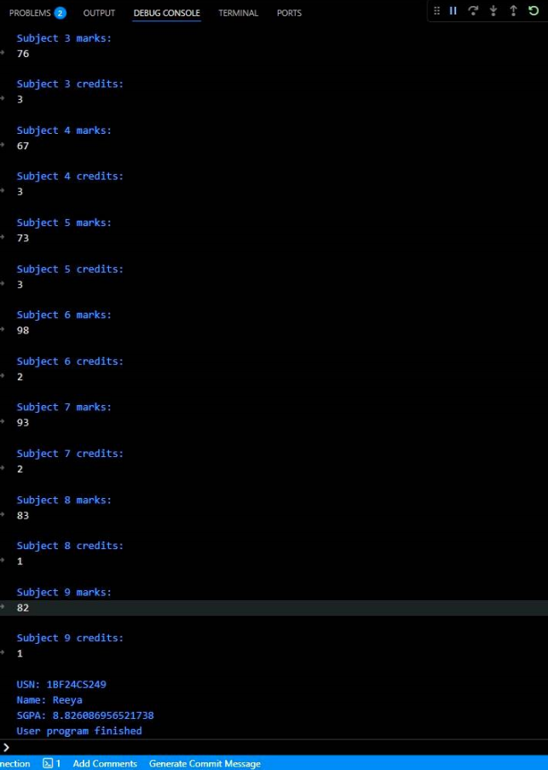

Program 3
Create a class Book which contains four members: name, author, price, num_pages. Include a constructor to set the values for themembers. Include methods to set and get the details of the objects.
Include a toString( ) method that could display the complete details ofthe book. Develop a Java program to create n book objects.

CODE:

import java.util.Scanner;

class Books {
String name;
String author;
int price;
int numPages;

Books(String name, String author, int price, int numPages) {
this.name = name;
this.author = author;
this.price = price;
this.numPages = numPages;
}

public String toString() {
String name = "Book name: " + this.name + "\n";
String author = "Author name: " + this.author + "\n";
String price = "Price: " + this.price + "\n";
String numPages = "Number of pages: " + this.numPages + "\n";
return name + author + price + numPages;
}
}

public class Main Books {
public static void main(String[] args) {
Scanner s = new Scanner(System.in);
System.out.print("Enter number of books: ");
int n = s.nextInt();
s.nextLine();

Books[] b = new Books[n];

for (int i = 0; i < n; i++) {
System.out.println("Enter details for book " + (i + 1) + ":");
System.out.print("Name: ");
String name = s.nextLine();
System.out.print("Author: ");
String author = s.nextLine();
System.out.print("Price: ");
int price = s.nextInt();
System.out.print("Number of pages: ");
int numPages = s.nextInt();
s.nextLine();
b[i] = new Books(name, author, price, numPages);
}

System.out.println("\nBook details:");
for (int i = 0; i < n; i++) {
System.out.println(b[i]);
}

s.close();
}}
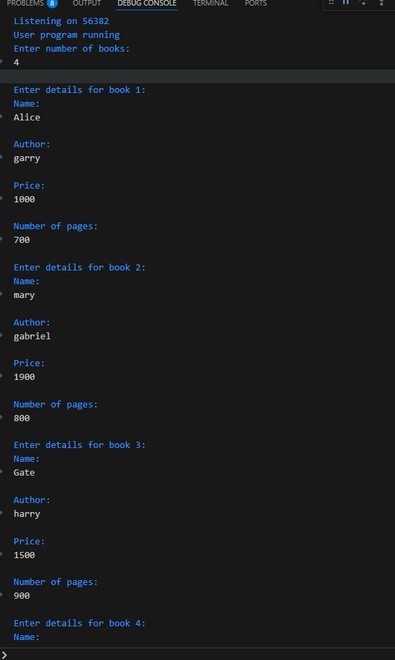
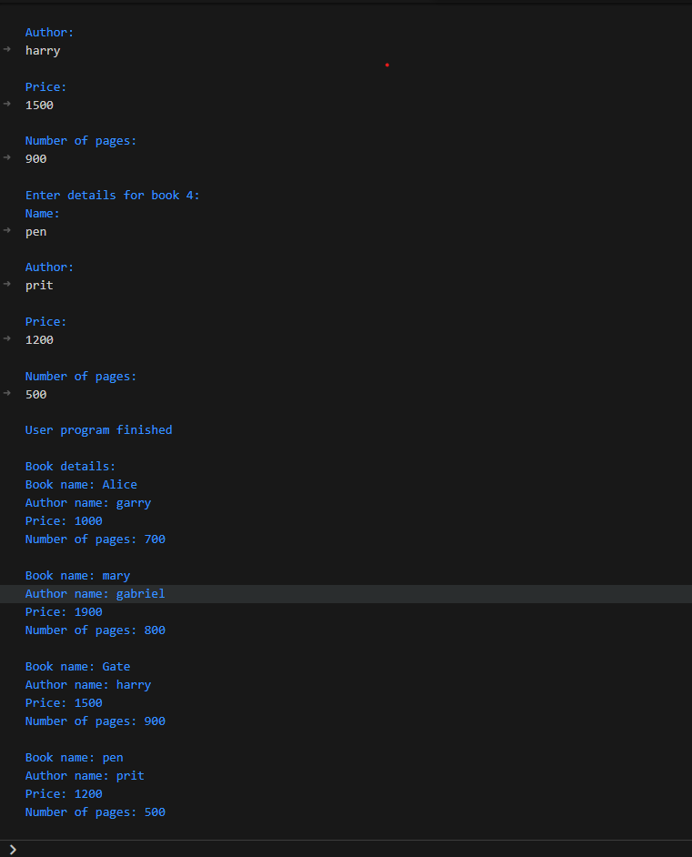

Program 4
Develop a Java program to create an abstract class named Shape that contains two integers and an empty method named printArea( ).Provide three classes named Rectangle, Triangle and Circle such thateach one of the classes extends the class Shape. Each one of the classes contain only the method printArea( ) that prints the area of the given shape.

CODE:

import java.util.Scanner;

class InputScanner {
Scanner sc = new Scanner(System.in);

int getInt(String msg) {
System.out.print(msg);
return sc.nextInt();
}

double getDouble(String msg) {
System.out.print(msg);
return sc.nextDouble();
}
}

abstract class Shape extends InputScanner {
int a, b;
abstract void printArea();
}

class Rectangle extends Shape {
void input() {
a = getInt("Enter length: ");
b = getInt("Enter breadth: ");
}

void printArea() {
System.out.println("Area of Rectangle = " + (a * b));
}
}

class Triangle extends Shape {
void input() {
a = getInt("Enter base: ");
b = getInt("Enter height: ");
}

void printArea() {
System.out.println("Area of Triangle = " + (0.5 * a * b));
}
}

class Circle extends Shape {
void input() {
a = getInt("Enter radius: ");
}

void printArea() {
System.out.println("Area of Circle = " + (3.1416 * a * a));
}
}

public class MainShape {
public static void main(String[] args) {
System.out.println("Enter the dimensions of rectangle:");
Rectangle r = new Rectangle();
r.input();
r.printArea();

System.out.println("\nEnter the dimensions of triangle:");
Triangle t = new Triangle();
t.input();
t.printArea();

System.out.println("\nEnter the dimension of circle:");
Circle c = new Circle();
c.input();
c.printArea();
}
}
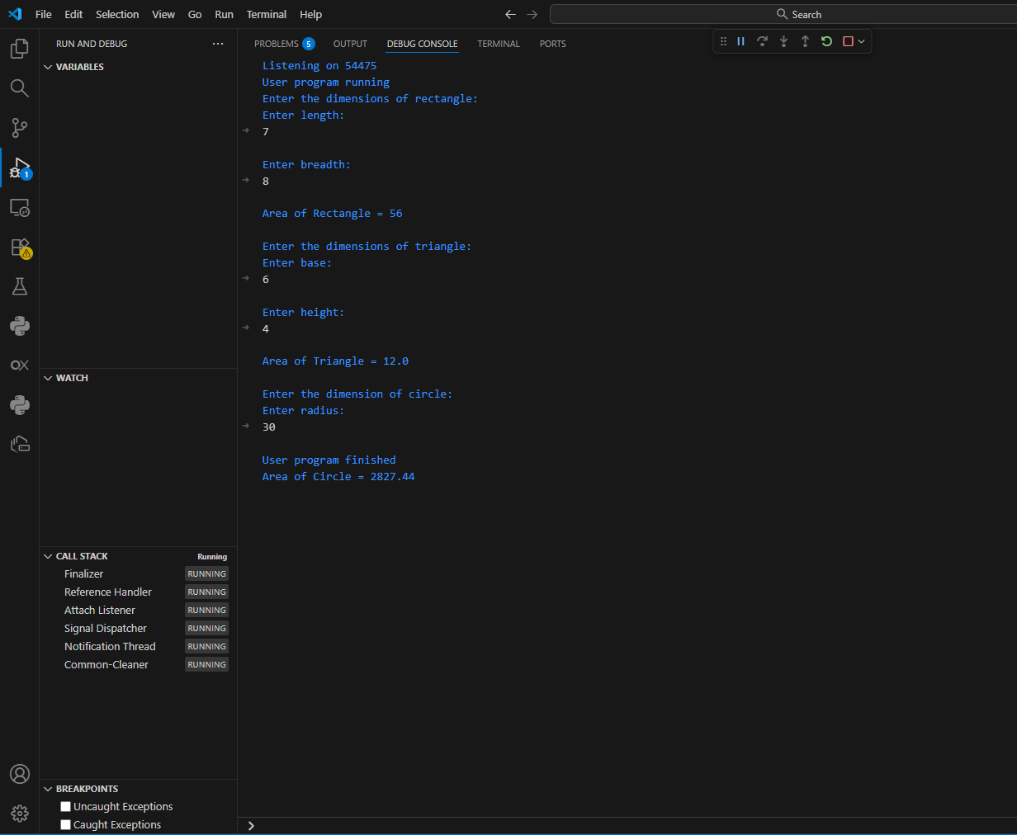

Program 5
Develop a Java program to create a class Bank that maintains two kinds of account for its
customers, one called savings account and the other current account. The savings account provides
compound interest and withdrawal facilities but no cheque book facility. The current account
provides cheque book facility but no interest. Current account holders should also maintain a
minimum balance and if the balance falls below this level, a service charge is imposed.

Create a class Account that stores customer name, account number and type of account. From this
derive the classes Cur-acct and Sav-acct to make them more specific to their requirements. Include
the necessary methods in order to achieve the following tasks:

a)Accept deposit from customer and update the balance.

b)Display the balance.

c)Compute and deposit interest

d)Permit withdrawal and update the balance

e) Check for the minimum balance, impose penalty if necessary and update the balance.

CODE:

import java.util.Scanner;

class Account {
String customerName;
int accountNumber;
String accountType;
double balance;

Account(String name, int accNo, String type) {
customerName = name;
accountNumber = accNo;
accountType = type;
balance = 0.0;
}

void deposit(double amount) {
balance += amount;
System.out.println("Deposited: " + amount + ". Updated balance: " + balance);
}

void display() {
System.out.println("Customer name: " + customerName);
System.out.println("Account number: " + accountNumber);
System.out.println("Type of Account: " + accountType);
System.out.println("Account Balance: " + balance);
}
}

class SavAcct extends Account {
SavAcct(String name, int accNo, String type) {
super(name, accNo, type);
}

void computeInterest() {
double rate = 0.04;
double interest = balance * rate;
balance += interest;
System.out.println("Interest added: " + interest + ". Updated balance: " + balance);
}

void withdraw(double amount) {
if (amount > balance) {
System.out.println("Insufficient balance!");
} else {
balance -= amount;
System.out.println("Withdrawn: " + amount + ". Updated balance: " + balance);
}
}
}

class CurAcct extends Account {
final double MIN_BAL = 500.0;
final double SERVICE_CHARGE = 100.0;

CurAcct(String name, int accNo, String type) {
super(name, accNo, type);
}

void checkBalance() {
if (balance < MIN_BAL) {
balance -= SERVICE_CHARGE;
System.out.println("Balance below minimum. Service charge imposed: " + SERVICE_CHARGE);
System.out.println("Updated balance: " + balance);
}
}

void withdraw(double amount) {
if (amount > balance) {
System.out.println("Insufficient balance!");
} else {
balance -= amount;
checkBalance();
System.out.println("Withdrawn: " + amount + ". Updated balance: " + balance);
}
}
}

public class Bank {
public static void main(String[] args) {
Scanner sc = new Scanner(System.in);
Account[] accounts = new Account[2];

for (int i = 0; i < 2; i++) {
System.out.print("Enter customer name: ");
String name = sc.nextLine();
System.out.print("Enter account number: ");
int accNo = Integer.parseInt(sc.nextLine());
System.out.print("Enter type of account (saving/current): ");
String type = sc.nextLine().toLowerCase();

if (type.equals("saving"))
accounts[i] = new SavAcct(name, accNo, type);
else
accounts[i] = new CurAcct(name, accNo, type);
}

int choice;
do {
System.out.println("\n-------MENU-------");
System.out.println("1. Deposit");
System.out.println("2. Withdraw");
System.out.println("3. Compute Interest for Savings Account");
System.out.println("4. Display Account Details");
System.out.println("5. Exit");
System.out.print("Enter your choice: ");
choice = sc.nextInt();

switch (choice) {
case 1:
System.out.print("Enter the type of account (saving/current): ");
String type = sc.next().toLowerCase();
System.out.print("Enter the deposit amount: ");
double depAmt = sc.nextDouble();
for (Account acc : accounts) {
if (acc.accountType.equals(type)) {
acc.deposit(depAmt);

break;
}
}
break;

case 2:
System.out.print("Enter the type of account (saving/current): ");
type = sc.next().toLowerCase();
System.out.print("Enter the withdrawal amount: ");
double wAmt = sc.nextDouble();
for (Account acc : accounts) {
if (acc.accountType.equals(type)) {
if (type.equals("saving"))
((SavAcct) acc).withdraw(wAmt);
else
((CurAcct) acc).withdraw(wAmt);

break;
}
}
break;

case 3:
System.out.print("Enter the type of account (saving/current): ");
type = sc.next().toLowerCase();
for (Account acc : accounts) {
if (acc.accountType.equals("saving") && type.equals("saving")) {
((SavAcct) acc).computeInterest();

break;
}
}
break;

case 4:
System.out.print("Enter the type of account (saving/current): ");
type = sc.next().toLowerCase();
for (Account acc : accounts) {
if (acc.accountType.equals(type)) {
acc.display();
break;
}
}
break;

case 5:
System.out.println("Exiting...");
break;

default:
System.out.println("Invalid choice!");
}
} while (choice != 5);

sc.close();
}
}
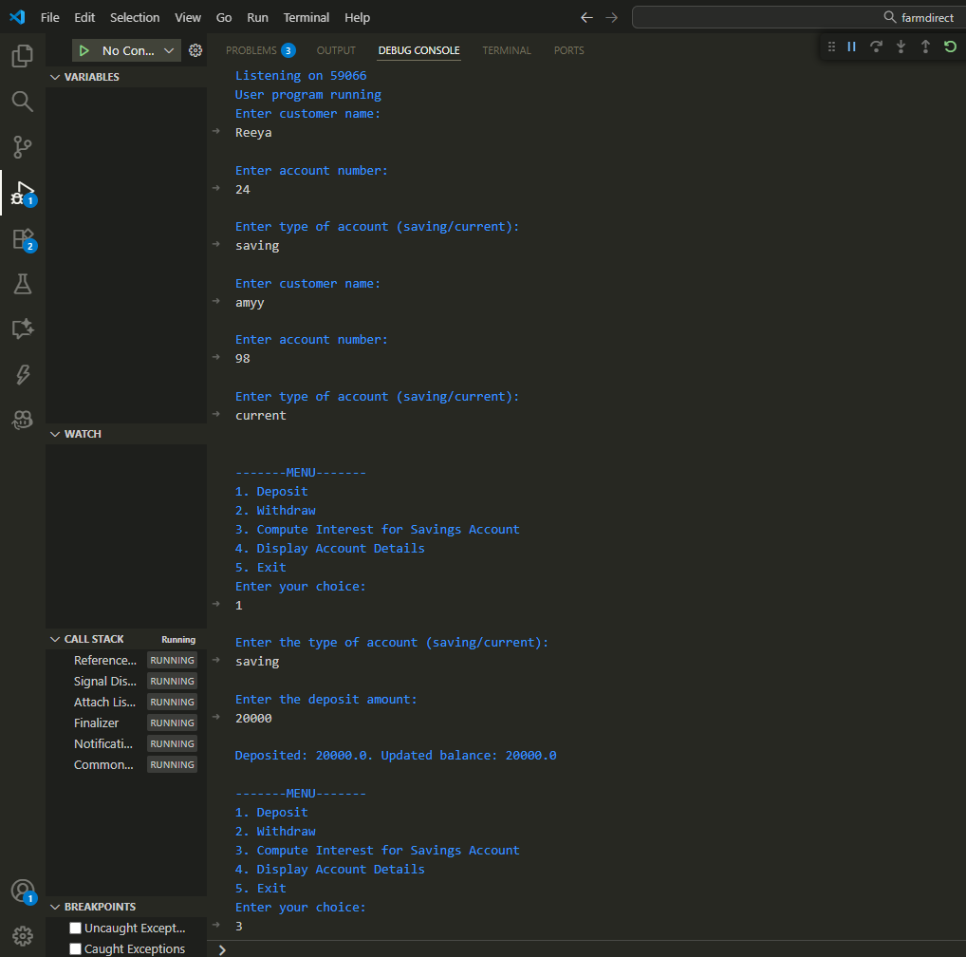
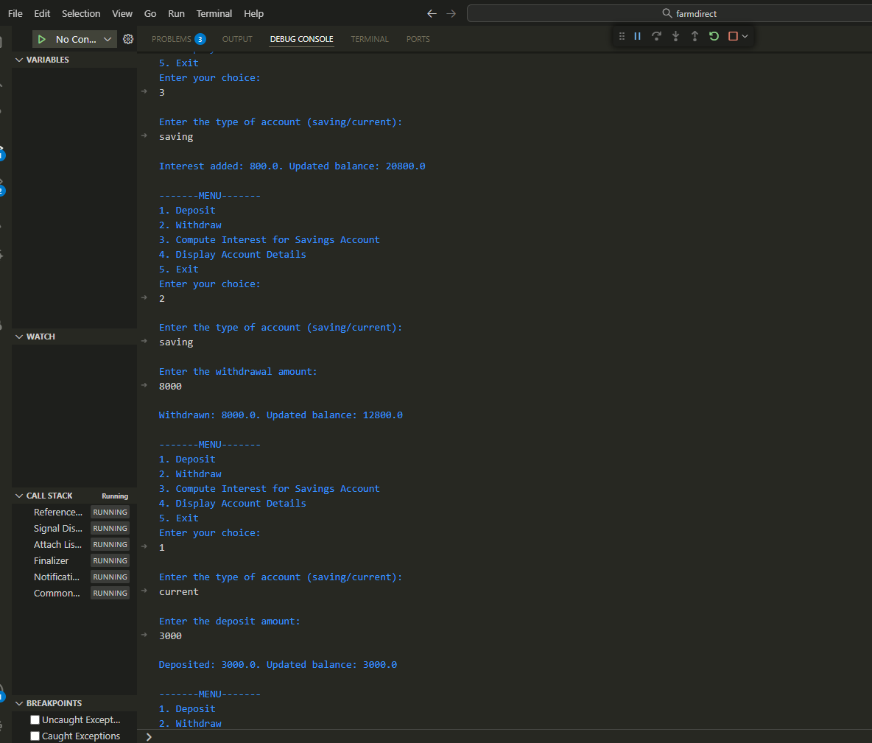

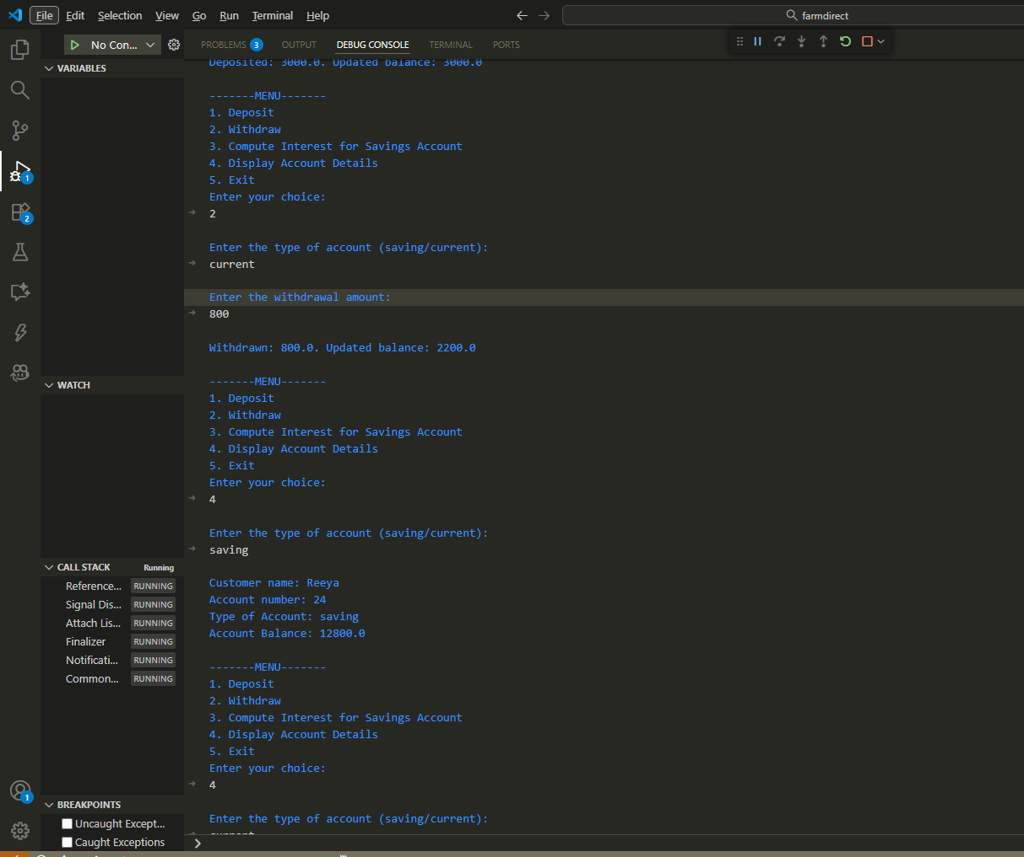
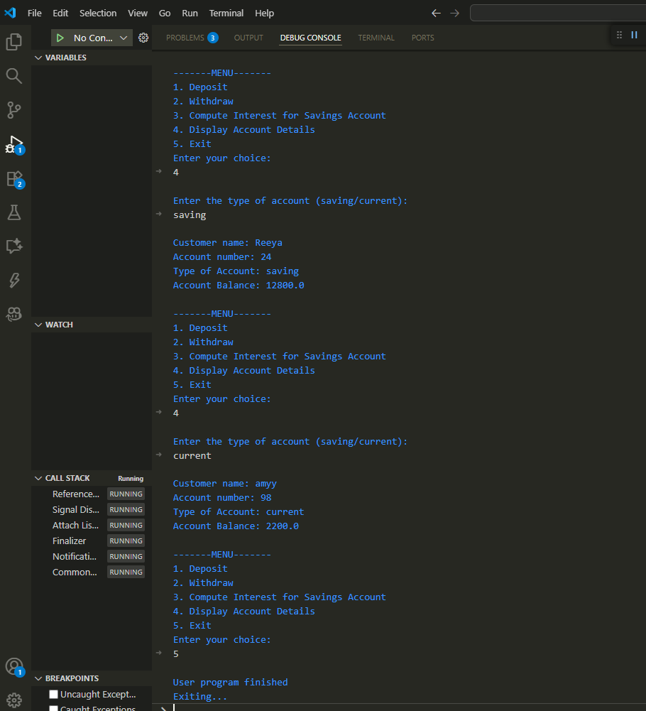

Program 6
Create a package CIE which has two classes- Student and Internals. The class Student has members like usn, name, sem. The class Internals derived from Student has an array that stores the internal marks scored in five courses of the current semester of the student. Create another package SEE which has the class External which is a derived class of Student. This class has an array that stores the SEE marks scored in five courses of the current semester of the student. Import the two packages in a file that declares the final marks of n students in all five courses.

CODE:

CIE:
- Student.java

package CIE;
import java.util.Scanner;

public class Student {
protected String usn;
protected String name;
protected int sem;

public void inputStudentDetails() {
Scanner s = new Scanner(System.in);
System.out.print("Enter USN: ");
usn = s.nextLine();

System.out.print("Enter Name: ");
name = s.nextLine();

System.out.print("Enter Semester: ");
sem = s.nextInt();
}

public void displayStudentDetails() {
System.out.println("USN: " + usn);
System.out.println("Name: " + name);
System.out.println("Semester: " + sem);
}
}

- Internals.java

package CIE;
import java.util.Scanner;

public class Internals extends Student {

protected int marks[] = new int[5];

public void inputCIEmarks() {
Scanner s = new Scanner(System.in);
System.out.println("Enter 5 CIE marks: ");

for (int i = 0; i < 5; i++) {
System.out.print("CIE Mark in Subject " + (i + 1) + ": ");
marks[i] = s.nextInt();
}
}
}

SEE:
- Externals.java

package SEE;

import CIE.Internals;
import java.util.Scanner;

public class Externals extends Internals {

protected int marks[];
protected int finalMarks[];

public Externals() {
marks = new int[5];
finalMarks = new int[5];
}

public void inputSEEmarks() {
Scanner s = new Scanner(System.in);
System.out.println("Enter 5 SEE marks: ");

for (int i = 0; i < 5; i++) {
System.out.print("SEE Mark in Subject " + (i + 1) + ": ");
marks[i] = s.nextInt();
}
}

public void calculateFinalMarks() {
for (int i = 0; i < 5; i++) {
finalMarks[i] = super.marks[i] + marks[i]/2; // CIE + SEE
}
}

public void displayFinalMarks() {
System.out.println("\n--- Final Marks ---");
displayStudentDetails();

for (int i = 0; i < 5; i++) {
System.out.println("Final Marks in Subject " + (i + 1) + ": " + finalMarks[i]);
}
}
}

Main.java

import SEE.Externals;

class Main {
public static void main(String args[]) {

Externals obj = new Externals();

obj.inputStudentDetails();
obj.inputCIEmarks();
obj.inputSEEmarks();
obj.calculateFinalMarks();
obj.displayFinalMarks();
}
}
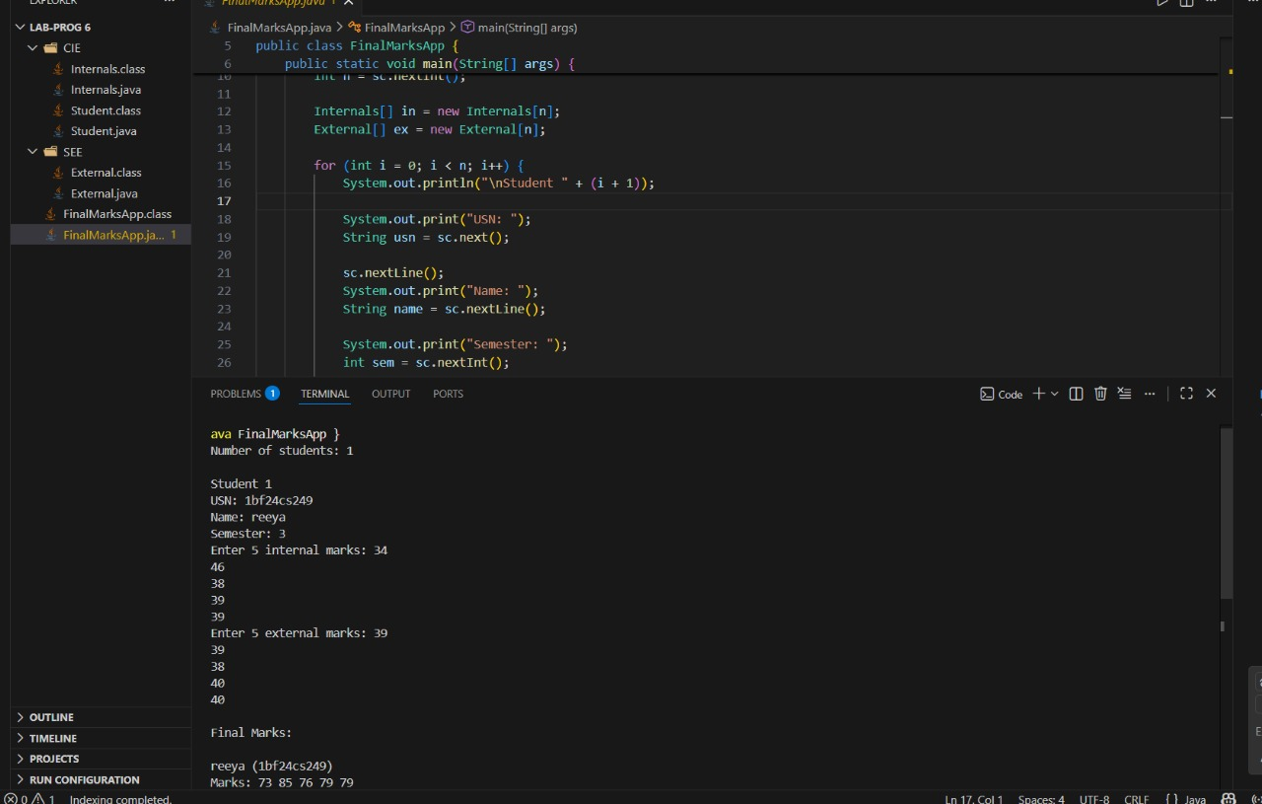

Program 7
Write a program that demonstrates handling of exceptions in inheritance tree. Create a base class called “Father” and derived class called “Son” which extends the base class. In Father class, implement a constructor which takes the age and throws the exception WrongAge( ) when the input age<0. In Son class, implement a constructor that cases both father and son’s age and throws an exception if son’s age is >=father’s age.

CODE:

import java.util.*;
class WrongAge extends Exception {
WrongAge() {
super("Age Error!");
}
WrongAge(String msg) {
super(msg);
}
}

class InputScanner {
Scanner s = new Scanner(System.in);
}
class Father extends InputScanner {
int fatherAge;

Father() throws WrongAge {
System.out.print("Enter father's age: ");
fatherAge = s.nextInt();

if (fatherAge < 0)
throw new WrongAge("Age cannot be negative");
}

void display() {
System.out.println("Father's age: " + fatherAge);
}
}
class Son extends Father {
int sonAge;
Son() throws WrongAge {
super();

System.out.print("Enter son's age: ");
sonAge = s.nextInt();

if (sonAge > fatherAge)
throw new WrongAge("Son's age cannot be greater than or equal to father's age");
else if (sonAge < 0)
throw new WrongAge("Age cannot be negative");
}

void display() {
System.out.println("Son's age: " + sonAge);
}
}
public class Main {
public static void main(String[] args) {
try {
Son obj = new Son();
System.out.println("\n--- Age Details ---");
obj.display();
obj.display();
} catch (WrongAge e) {
System.out.println("Exception caught: " + e.getMessage());
}
}
}
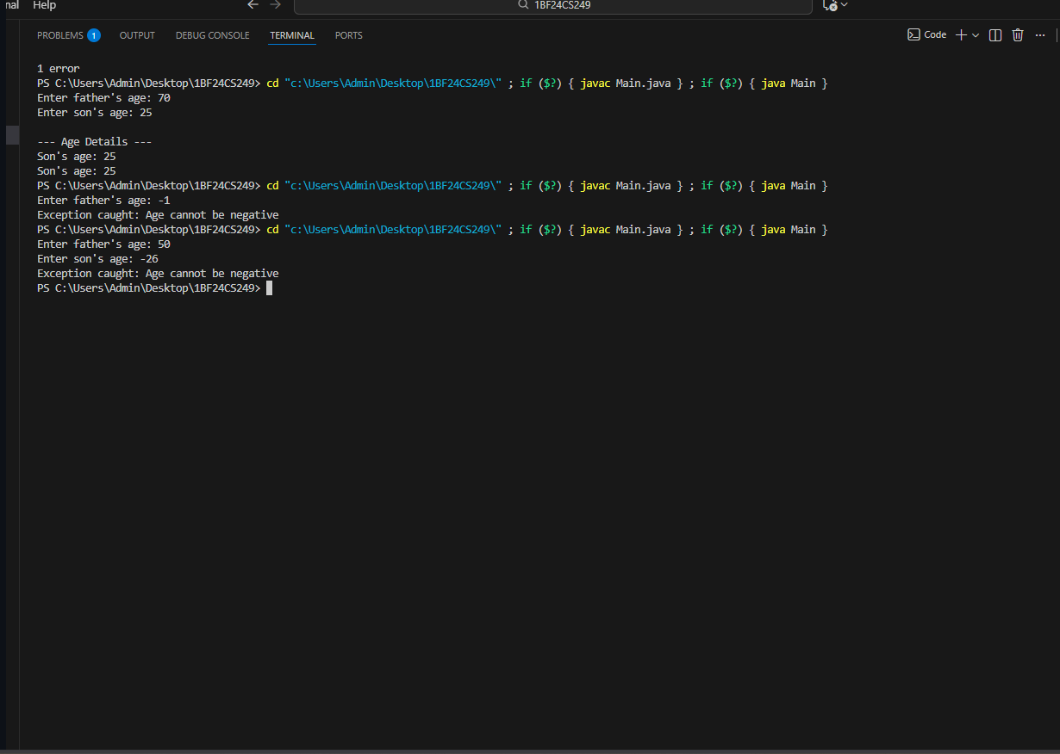

Program 8
Write a program which creates two threads, one thread displaying “BMS College of Engineering” once every ten seconds and another displaying “CSE” once every two seconds.

CODE:

class MsgPrinter implements Runnable {
String message;
int interval;

MsgPrinter(String message, int interval) {
this.message = message;
this.interval = interval;
}

public void run() {
try {
while (true) {
System.out.println(message);
Thread.sleep(interval);
}
} catch (InterruptedException e) {
System.out.println("Thread interrupted");
}
}
}

public class Main {
public static void main(String[] args) {
Thread t1 = new Thread(new MsgPrinter("BMS College of Engineering", 10000));
Thread t2 = new Thread(new MsgPrinter("CSE", 2000));

t1.start();
t2.start();
}
}
